DAT 510 uCertify Lab Activity Worksheet

Aubrey Waddle

Module Labs
Module Three

Lab Screenshots

Lab 3.6.1
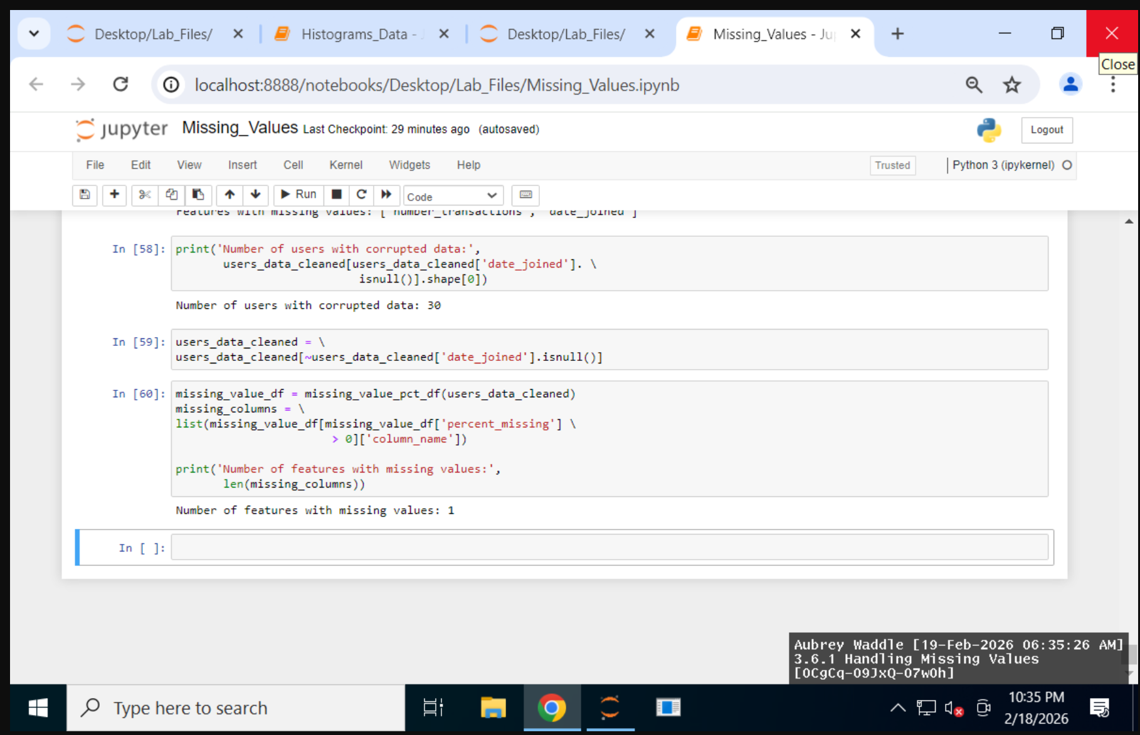

Lab 3.6.2
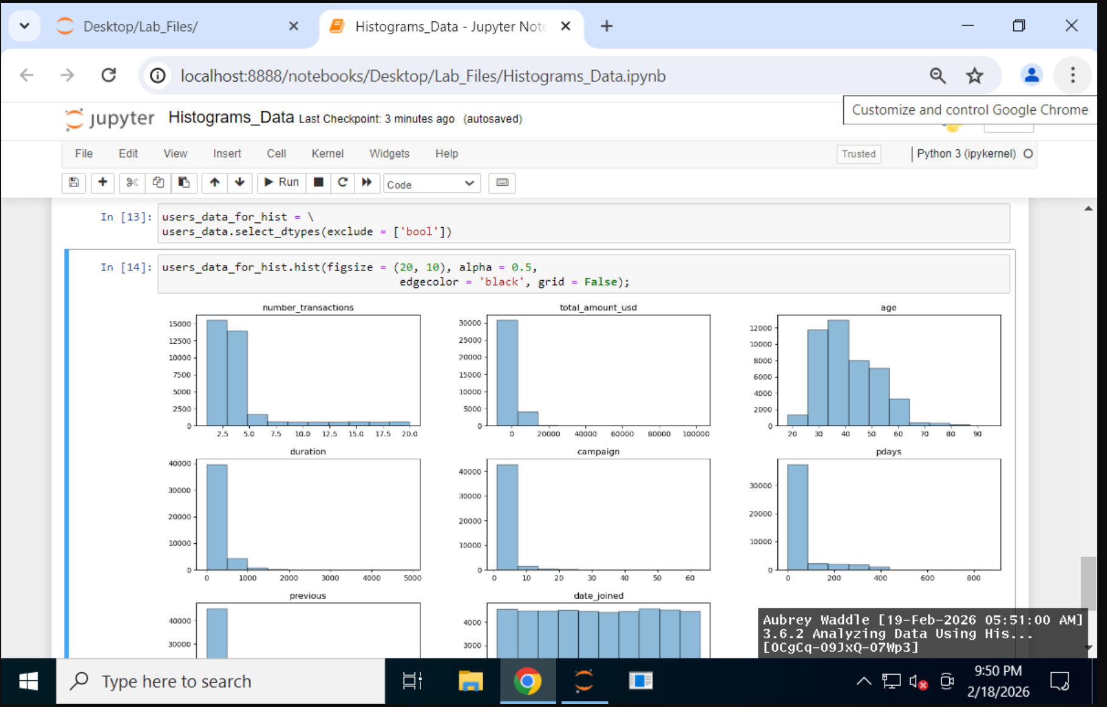

Lab Reflection

Lab 3.6.1
The Pandas package is mostly used in this lab to get the data ready for analysis. Those were the main things to do. Use isnull() to find values that are missing.Use mean() to find out what percentage of values are missing. Use sort_values() to sort features by how many missing values they have, and use drop() to get rid of columns with a lot of missing values. Use select_dtypes() to tell the difference between numerical and categorical variables. Use fillna() to fill in missing values in a certain way. A new function that makes modular coding and reproducibility easier was also used to make a structured report on how much data was missing. I am not sure why I ran through the lab twice but one of my features still had missing values.

You need these tools and methods to get data ready for analysis or modeling. This is very helpful for technical people like data scientists and analysts.

Lab 3.6.2
The Pandas library was mostly utilized in the lab to choose numerical features, and Matplotlib's built-in Pandas visualization tools were used to generate histograms. They achieved this by using Jupyter Notebook and Python. Using the.select_dtypes() function, the relevant numeric columns were separated, and the.hist() method with particular options like figsize, alpha, and edgecolor made the data easier to read. This provides features like filtering and the ability to quickly display the distribution of numerous variables, which are useful for exploratory data analysis (EDA).

The histograms show the distribution's shape, degree of skewness, and possible outliers for variables like age, number_transactions, and total_amount_usd. For technical audiences such as data scientists and analysts, these visualizations are especially useful since they help evaluate normalcy assumptions, identify extreme values, and support preprocessing or modeling decisions.

